Quantitative Literacy FIG
Winter 2020

Facilitator Information:
Name: Paula Thonney Department: Mathematics

Member Information:
Paula Thonney, Math
Molly Beick, Math
Reza Oskui
Cullen Andrews, Math

Introduction:
Today’s world requires more sophisticated quantitative skills as the amount of information and data we encounter increases in quantity and complexity. Rather than following rote instructions, students need to develop skills to work in a variety of different real contexts and to apply appropriate strategies in order to explore, reason, and evaluate arguments. Many faculty never took a quantitative literacy course in college, so we may be applying methods that aren’t well-aligned with what today’s students need.

Math 098 or Math Literacy is a relatively new course. Those of us who have been teaching it would like to learn more about existing research or strategies for successfully developing QL in our students.

- What is Quantitative Literacy?
- What is the value of Quantitative Literacy to a community college student in the alternate pathway?
- How does teaching Quantitative Literacy differ from teaching a traditional mathematics course?
- How do we help our students:
  - develop mathematical intuition
  - communicate their thought process
  - justify their reasoning
  - evaluate conclusions that others draw based on data
- How do we evolve our role and our teaching methods to more effectively develop quantitative literacy in our students?
- How can our students be more actively engaged in constructing their own understanding?

Meeting #1 1/17/2020 from 12-1 in 16/189

Attending:
Cullen Andrews, Molly Beick, Reza Oskui, Paula Thonney

Notes:
We reviewed the article “Helping Students Become Quantitatively Literate” by Katrina Piatek-Jimenez, Tibor Marcinek, Christine M. Phelps, and Ana Dias.

Quantitative Literacy is using basic math skills but in an adult context from real life. Content includes number sense, measurement, data analysis, risk, chance, finance, money, percentages, rate of change, reading graphs. This aligns well with topics we cover in Math 020, 098, 105 and 243.

Real life contexts include work/career, civic or global issues (climate change is a good example), and private life (finance comes to mind). We want our students to be intelligent consumers of magazine & newspaper articles, including graphs & statistics.

One topic we explored is the inherent complexity of real life situations. The “Cost of Driving” project we use in Math 098 is a good example, where there is no way to create a model without oversimplifying reality to some extent. The key is to find a model that has enough complexity to be realistic and believable, without being paralyzing and impossible to work with.

Meeting #2 1/31/2020 from 12-1 in 16/208

We discussed examples on pages 91-101, some of which were quite tricky or subtle.
One example mentioned the GINI coefficient for inequality, which represents the area between the line of equality and the curve of inequality, or the income distribution.
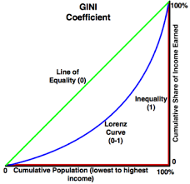
It took us a while to understand the concept. The book didn’t clarify that the x axis is organized from lowest to highest income), and Molly asked whether the (Lorenz) curve could ever go above the line of equality. We were pretty sure it couldn’t. It was a good opportunity for us to use our own QL skills in a context we weren’t familiar with.

We looked at gapminder.org>>tools where there is a wealth of data presented in the form of scatter plots where each country has a dot, and there is a time based animation. You can also customize what is presented on each axis. The site was developed by Hans Rosling, author of Factfulness.

We looked at the way the data was presented in example 1 on page 97. The article stated that only 7% of students took an opportunity, but the data could have been presented with a different denominator, and stated that 66% of students took the opportunity. This is a good example of how you can “spin” the facts depending on the point you are trying to make.

Cullen: The Third R: Quantitative Literacy pages 3- 11
Cullen summarized his reading for us with the following notes:
-arithmetic no longer sufficient, literacy is more sophisticated, arithmetic + complex reasoning
-students need continued reflective experience with data
-college is replacing high school as the standard, but the math curriculum is narrowing (calculus bottleneck)
-in other areas students choose electives & majors
-math hasn’t evolved since 1800, must go through bottleneck of calculus before branching out
-we want QL to be accessible to all majors
-people draw conclusion about math in general from calculus specifically (or they have)
-high stakes testing gives people a negative impression (as well as anxiety) about math

Meeting #3 2/14/2020 from 12-1 in 16/208

Molly: QL in Higher Education pages 13 - 19
- The overall theme here seemed to be around the challenges of implementing QL in higher ed.
- High schools won’t adopt QL (or respect it) until colleges show a value for QL.
- Community colleges serve their transfer institutions so what does QL look like at U of O and at OSU? Cullen said that at U of O the physics department does a good job of giving students real data and applications (a course on energy efficient homes for example). The physics courses serve non majors as well as majors.
- QL needs to be considered outside of math (we are serving non-math disciplines, so we need to work with them to get good applications and find out what their needs are).
- The needs of Science and Social Science majors differ. Contexts are different.
- Math organizes their thinking (Reza).
- Math is not a discipline but a way of thinking (hmm…)
- Sometimes QL is viewed as remedial (not valued or respected by faculty). Students seem to value it (especially if it is done well). But it’s tough to do well.
- In order to do QL right, we need to consult with other disciplines, be informed by them.
- “The fear of QL recreates the need for QL.” A rather cryptic statement...does it refer to the fact that QL is unfamiliar to us, so we need more of it, not less?
- Effective QL is about methods, not just content.

Paula: Educational Goals for QL pages 21 - 26

-Literacy involves interpretation, understanding, the power of language
-Basic math skills may be the same as in elementary/middle school. In high school & increasingly so in college, we have more nuanced & complex applications rooted in real life
-An algorithmic process offers a series of steps that get you to the answer. QL “adds a dimension of rigor and thoughtfulness” in challenging settings such as political, scientific, and historical or artistic contexts
-The list of examples to investigate on page 22 is pretty challenging! I would not be ready to tackle those without significant preparation. Yes the math is simple, but the contexts are unfamiliar to me. Also they are messy!
-QL is the ability to identify, understand, and engage, to make well founded arguments for life as a citizen (quantitative aspect of our democracy, of fairness, is emphasized)
-QL serves a broader range of students than the traditional curriculum.
-QL is the ability to apply quantitative ideas in unfamiliar contexts. Can they transfer insights from one experience to an unrelated one?
-A QL mind searches for patterns rather than following instructions; it is less passive, more active. It reasons, argues, arrives at insights.
-Adaptive reasoning is flexible. We might need to make decisions without full information.
-Number sense encompases not just numbers but also a sense of space, chance, and data. Not just computation but also reasoning, argument, insight.
“What do you notice, what do you wonder?” at the beginning, then again after learning a skillset/framework.

away | toward
follow these steps to get to the right answer | which of the concepts/frameworks we learned would be helpful to apply in this context
simplistic problems | rich contexts
contrived | realistic  (the challenge here is to find a context that isn’t TOO messy)
doing problems | reading articles, answering higher level questions
 | explaining concepts
learning math vocabulary for objects and processes
nouns: ratio, proportion, graph, data, percent increase, rate of change
verbs: scaling, comparing, measuring growth
do this thing | what tool would be useful in this context?
following rules | thinking for yourself, actively questioning

Meeting #4 2/28/2020 from 12-1 in 16/208

Reza: Importance of QL pages 27 - 32

Quantitative literacy can focus on money or democracy or personal welfare or decision making. Health, safety, taxes, and budget are good application problems. Reza mentioned a friend of his with a masters in math who is working for Walmart in decision making. Apparently the demand for quantitative literacy is greater than the supply of people qualified to work in these applied math fields.

From page 32: “...public health officials worry that patients’ innumeracy can lead to misinterpretation of medical advice or health-related new…”

Cullen shared this article on teaching data & statistics using the corona virus outbreak. When the data we are using is really fresh, we have no idea what the long-term trend will be. It’s much more uncertain and engaging than old data where the conclusions are fairly well agreed upon.

Paula shared this graph of various diseases plotted on a coordinate system where the horizontal axis represents contagiousness and the vertical axis represents the percent fatality rate. The skill of reading graphs and paying attention to what each axis is measuring. This graph happens to have a logarithmic scale which students are not likely to be familiar with.

Molly shared an activity she worked on with her students from the carbon footprint calculator spreadsheet in Math 098. She wanted the students to have a better understanding of a variable (such as an individual’s car’s gas mileage, or the number of miles a person drives) vs. constants (the number of grams of CO2 emitted by burning one gallon of gas, or the grams of CO2 emitted by a bus that drives 1 mile).

We discussed that a more tangible or relatable example might be different pay models, such as hourly pay, pay by commission, or tips. Variables in this case could be the hours worked, or the amount of sales made. Constants would be a person’s hourly wage, their commision rate, or the % tip they earn if paid by the employer.

Meeting #5 3/13/2020 5:30 meet at Hometown Buffet Restaurant

Discuss Final Readings - what can you use from what you have read? Did you find a way to apply it?

We each read further into the book, but didn’t find a lot of specific examples that could be brought into the classroom. The book does a good job of describing the challenges but not of providing solutions.

What resources are available online? There is a section in the back of the book so I followed some online searches to find the following:

National Numeracy Network
- How to Choose and Use an Article**
- Blog: Thinking Quantitatively
- Numeracy Journal

Quantitative Literacy at Dartmouth College

Hollins University: Interdisciplinary Quantitative Reasoning

MacAlester College: Quantitative Thinking

Trinity College: Northeast Consortium for Quantitative Literacy (NECQL)

Reza suggested we create our own database of QL problems or articles. I was thinking in terms of Math Literacy, or Math 098, but he pointed out that we could and should be thinking of ways to integrate QL into other/all math courses as well.

Topics Reza suggested include unit conversions, stock market, choosing a pricing structure for a car rental (flat rate vs. mileage), if side doubles, does area double (in a circle/pizza)?

...

Cullen used Google Scholar to locate articles that referenced our book. He came across “Assessing Quantitative Literacy in Higher Education” and gave us each a copy of Table 4 which outlines various components of QL. I found it very useful.

Problem Solving Skills are: Interpretation, Strategic Knowledge and Reasoning, Modeling, Computation, and Communication. Content Areas are: Number and Operations, Algebra, Geometry and Measurement, Statistics and Probability. Contexts are: Personal/Everyday Life, Workplace, Society.

…

Molly suggested that while context driven applications are engaging for adult students, perhaps when we are looking to engage younger students, we might focus on fun patterns and pure math. It’s an interesting dilemma as the math in real applications can be messier, and the pure theoretical math can be very beautiful in an abstract way. What is more engaging to students? It may depend on the student’s personal preference. However I like Molly’s challenge to value pure math for its fun potential and ability to engage students as well.

…

I (Paula) shared with the group that I had discovered that a pareto chart (a bar graph with bars organized from highest to lowest) is named for an italian sociologist/economist who generated the 80/20 principle: 80% of the effects are driven by 20% of the causes. I discovered the 80/20 principle when reading about time management, but it can be applied in many contexts.

I would like to find more of these interdisciplinary concepts to weave into my math curriculum. A Pareto chart and its underlying idea is more engaging than a simple bar graph, which is too elementary for students in our class. I came across the following graph attempting to place the corona virus in perspective among other world diseases. Looking back on it now I am not sure it is a good choice but at the time I presented it, I thought that the fear surrounding the virus was overblown. Below is a similar graph that doesn’t include the coronavirus.

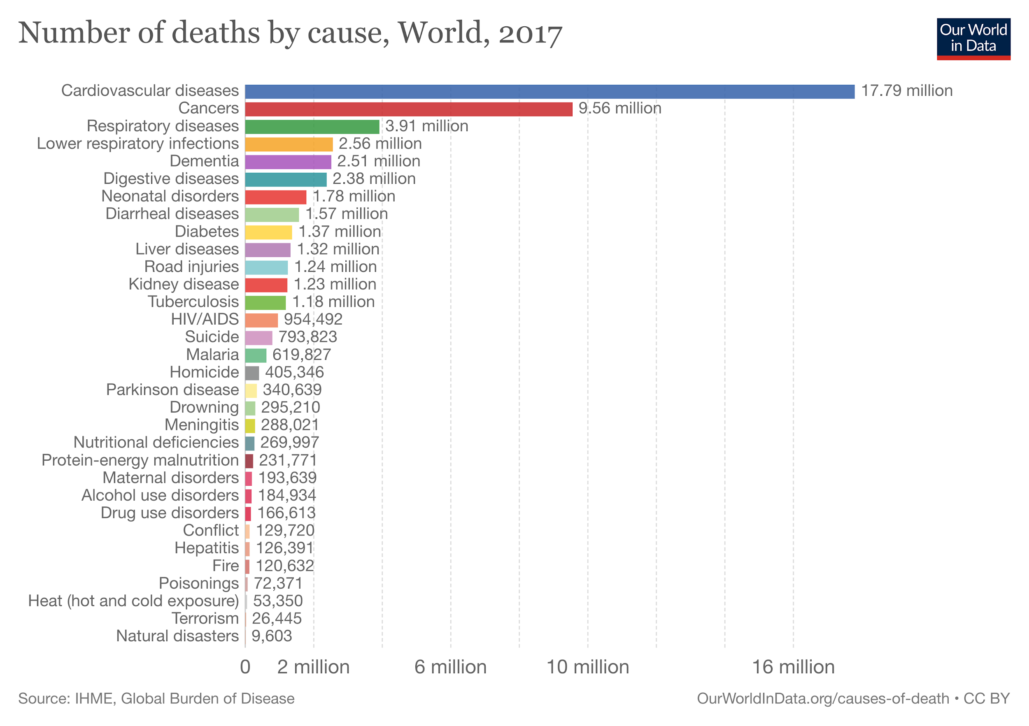
Summary of Findings:

I think all four of us were able to explore QL in a variety of directions. We found examples and generated our own from our readings online, in news articles, and from our lives. We feel validated in continuing to include QL in our courses. Rather than overhauling an entire course, we can include an excerpt of an article as a warm up for discussion. This makes integrating QL into our courses simpler. It’s also important to use current examples rather than old data, so we need to be able to quickly share current events with our students.

I hope to apply the How to Choose and Use an Article resource into a redesign of Math Literacy (MTH 098). Currently the course uses the global climate crisis as one of its contexts. However the course needs to be free to evolve and update, as well as to be tailored to each instructor’s interests and preferences.

Thank you to the LCC Faculty Professional Development Committee for supporting us in our research into Quantitative Literacy this term!

Sincerely,

Paula
(on behalf of the group: Cullen, Molly, Paula, and Reza)
