Chabot College
Academic Program Review Report

Year One of
Program Review Cycle

Ethnic Studies

Submitted on March 8
[Name of Contact Person/Preparer]

Final Forms, 1/18/13
Table of Contents

Section 1: Where We've Been 1
Section 2: Where We Are Now 2
Section 3: The Difference We Hope to Make 3

Required Appendices:

A: Budget History 4
B1: Course Learning Outcomes Assessment Schedule 5
B2: “Closing the Loop” Assessment Reflections 6
C: Program Learning Outcomes 9
D: A Few Questions 12
E: New Initiatives 13
F1: New Faculty Requests 14
F2: Classified Staffing Requests 15
F3: FTEF Requests 16
F4: Academic Learning Support Requests 17
F5: Supplies and Services Requests 18
F6: Conference/Travel Requests 19
F7: Technology and Other Equipment Requests 20
F8: Facilities Requests 21

1. Where We've Been

Complete Appendix A (Budget History) prior to writing your narrative. Limit your narrative to no more than one page.

As you enter a new Program Review cycle, reflect on your achievements over the last few years. What did you want to accomplish? Describe how changes in resources provided to your discipline or program have impacted your achievements. What are you most proud of, and what do you want to continue to improve?

Currently, there are no faculty members officially designated as program coordinators of Ethnic Studies. Faculty members from History, Sociology and Anthropology have attempted to watch out for the program, but must prioritize the administrative responsibilities for which they are responsible.

As a result, work in and advocacy for the program has been sporadic and inconsistent. Attached to this document is part of a sabbatical report (undertaken by Michael Thompson) that compares Chabot’s Ethnic Studies program to similar programs at neighboring community colleges. Among the recommendations within this report are:
- Hiring a full-time faculty member to revitalize the program (Within this review and that of the History discipline are requests for a joint History/Ethnic Studies hire)
- Review of and expansion of the courses eligible for Ethnic Studies
- Review of current American Cultures Requirement for possible expansion from comparative-only courses to courses that are either comparative OR focused on one ethnic/racial minority.

2. Where We Are Now

Review success, equity, course sequence, and enrollment data from the past three years at http://www.chabotcollege.edu/ProgramReview/Data2012.cfm. Please complete Appendices B1 and B2 (CLO's), C (PLO's), and D (A few questions)before writing your narrative. Limit your narrative to two pages.

After review of your success and retention data, your enrollment trends, your curriculum, and your CLO and PLO results, provide an overall reflection on your program. Consider the following questions in your narrative, and cite relevant data (e.g., efficiency, persistence, success, CLO/PLO assessment results, external accreditation demands, etc.):

- What are the trends in course success and retention rates (based on overall results and CLO assessments) in your program? Do you see differences based on gender and/or ethnicity? Between on-campus and online or hybrid online courses? Provide comparison points (college-wide averages, history within your program, statewide averages).
- What changes are you seeing in enrollments in your courses and overall program, and what is driving those changes?
- Describe how changes in investments--or lack thereof (funding, adding units to courses or adding supplemental instruction courses, adding or increasing student learning support, adding courses to sequences, classified staff, etc.) have impacted student learning in both specific courses, course sequences, and overall programs.
- For PLOs, have you collaborated with colleagues in other disciplines to look at “whole programs” or "whole GE areas"? What insights have you gained from these collaborations?
Ethnic studies courses simply aren’t regularly offered at Chabot. Ethnic Studies 3 (Muslims in America) has been offered recently. Ethnic Studies 1 (Introduction to Ethnic Studies) is being offered this semester for the first time in over 2 years.

Simply put, the college has simply not invested in the program. In the competition for dwindling resources, Ethnic Studies has lost out. A significant commitment to the program through the hiring of a full time faculty member tasked with revitalization could result in the re-establishment of an important pathway for our diverse student body.

3. The Difference We Hope to Make

Review the Strategic Plan goal and key strategies at http://www.chabotcollege.edu/prbc/StrategicPlan/SPforPR.pdf prior to completing your narrative. Please complete Appendices E (New Initiatives) and F1-8 (Resource Requests) to further detail your narrative. Limit your narrative to three pages, and be very specific about what you hope to achieve, why, and how.

What initiatives are underway in your discipline or program, or could you begin, that would support the achievement of our Strategic Plan goal? Over the next three years, what improvements would you like to make to your program(s) to improve student learning? What are your specific, measurable goals? How will you achieve them? Would any of these require collaboration with other disciplines or areas of the college? How will that collaboration occur?

Revitalization of the Ethnic Studies program would result in the timely and consistent measurement of program curriculum and goals. It would renew an important course of study for our students and, perhaps most importantly, serve as a hub for initiatives that currently exist on the campus. For example, a vibrant Ethnic Studies program could provide a pathway for 2nd year support for some students currently in the Daraja and Puente learning communities. Ethnic Studies could also serve as a location for curricular development to reflect Chabot’s designation as a Hispanic Serving Institution. Lastly, a revitalized program could begin to expand the offerings available to students which focus upon the histories and cultures of Asia and the Pacific Islands.

Appendix A: Budget History and Impact

Audience: Budget Committee, PRBC, and Administrators
Purpose: This analysis describes your history of budget requests from the previous two years and the impacts of funds received and needs that were not met. This history of documented need can both support your narrative in Section A and provide additional information for Budget Committee recommendations.
Instructions: Please provide the requested information, and fully explain the impact of the budget decisions.

Category | 2011-12 Budget Requested | 2011-12 Budget Received | 2012-13 Budget Requested | 2012-13 Budget Received
Classified Staffing (# of positions)
Supplies & Services
Technology/Equipment
Other
TOTAL

- How has your investment of the budget monies you did receive improved student learning? When you requested the funding, you provided a rationale. In this section, assess if the anticipated positive impacts you projected have, in fact, been realized.

- What has been the impact of not receiving some of your requested funding? How has student learning been impacted, or safety compromised, or enrollment or retention negatively impacted?

Appendix B1: Course Learning Outcomes Assessment Schedule

All courses must be assessed at least once every three years. Please complete this chart that defines your assessment schedule.

ASSESSMENT SCHEDULE:
 | Spring 2013 | Fall  2013 | Spring 2014 | Fall  2014 | Spring 2015 | Fall  2015 | Spring 2016 | Fall  2016 | Spring 2017
Courses:
Group 1: | Full Assmt | Discuss results | Report Results |  |  |  | Full Assmt | Discuss results | Report Results
Group 2: |  | Full Assmt | Discuss results & report
Group 3: |  |  | Full Assmt | Discuss results | Report Results
Group 4: |  |  |  | Full Assmt | Discuss results & report

Appendix B2: “Closing the Loop” Assessment Reflections

Course
Semester assessment data gathered
Number of sections offered in the semester
Number of sections assessed
Percentage of sections assessed
Semester held “Closing the Loop” discussion
Faculty members involved in “Closing the Loop” discussion

Form Instructions:
- Part I: CLO Data Reporting. For each CLO, obtain Class Achievement data in aggregate for all sections assessed in eLumen.
- Part II: CLO Reflections. Based on student success reported in Part I, reflect on the individual CLO.
- Part III: Course Reflection. In reviewing all the CLOs and your findings, reflect on the course as a whole.

Part I: Course-Level Outcomes – Data Results
Consider The Course-Level Outcomes Individually (the Number of CLOs will differ by course) | Defined Target Scores*  (CLO Goal) | Actual Scores** (eLumen data)
(CLO) 1:
(CLO) 2:

(CLO) 3:

(CLO) 4:
If more CLOs are listed for the course, add another row to the table.
* Defined Target Scores: What scores in eLumen from your students would indicate success for this CLO? (Example: 75% of the class scored either 3 or 4)
**Actual scores: What is the actual percent of students that meet defined target based on the eLumen data collected in this assessment cycle?

Part II: Course- level Outcome Reflections

- Course-Level Outcome (CLO) 1:
- How do your current scores match with your above target for student success in this course level outcome?

- Reflection: Based on the data gathered, and considering your teaching experiences and your discussions with other faculty, what reflections and insights do you have?

- Course-Level Outcome (CLO) 2:
- How do your current scores match with your above target for student success in this course level outcome?

- Reflection: Based on the data gathered, and considering your teaching experiences and your discussions with other faculty, what reflections and insights do you have?

C. Course-Level Outcome (CLO) 3:
- How do your current scores match with your above target for student success in this course level outcome?

- Reflection: Based on the data gathered, and considering your teaching experiences and your discussions with other faculty, what reflections and insights do you have?

D. Course-Level Outcome (CLO) 4:
- How do your current scores match with your above target for student success in this course level outcome?

- Reflection: Based on the data gathered, and considering your teaching experiences and your discussions with other faculty, what reflections and insights do you have?

E. Course-Level Outcome (CLO) 5: Add if needed.

Part III: Course Reflections and Future Plans

- What changes were made to your course based on the previous assessment cycle, the prior Closing the Loop reflections and other faculty discussions?

- Based on the current assessment and reflections, what course-level and programmatic strengths have the assessment reflections revealed? What actions has your discipline determined might be taken as a result of your reflections, discussions, and insights?

- What is the nature of the planned actions (please check all that apply)?
- Curricular
- Pedagogical
- Resource based
- Change to CLO or rubric
- Change to assessment methods
- Other:_________________________________________________________________

Appendix C: Program Learning Outcomes

Considering your feedback, findings, and/or information that has arisen from the course level discussions, please reflect on each of your Program Level Outcomes.

Program: ________________________________________________
- PLO #1:

- PLO #2:

- PLO #3:

- PLO #4:

What questions or investigations arose as a result of these reflections or discussions?
Explain:

What program-level strengths have the assessment reflections revealed?
Strengths revealed:

What actions has your discipline determined might be taken to enhance the learning of students completing your program?
Actions planned:

Program: ________________________________________________
- PLO #1:

- PLO #2:

- PLO #3:

- PLO #4:

What questions or investigations arose as a result of these reflections or discussions?
Explain:

What program-level strengths have the assessment reflections revealed?
Strengths revealed:

What actions has your discipline determined might be taken to enhance the learning of students completing your program?
Actions planned:

Appendix D: A Few Questions

Please answer the following questions with "yes" or "no". For any questions answered "no", please provide an explanation. No explanation is required for "yes" answers :-)

- Have all of your course outlines been updated within the past five years? If no, identify the course outlines you will update in the next curriculum cycle. Ed Code requires all course outlines to be updated every six years.

- Have all of your courses been offered within the past five years? If no, why should those courses remain in our college catalog?

- Do all of your courses have the required number of CLOs completed, with corresponding rubrics? If no, identify the CLO work you still need to complete, and your timeline for completing that work this semester.

- Have you assessed all of your courses and completed "closing the loop" forms for all of your courses within the past three years? If no, identify which courses still require this work, and your timeline for completing that work this semester.

- Have you developed and assessed PLOs for all of your programs? If no, identify programs which still require this work, and your timeline to complete that work this semester.

- If you have course sequences, is success in the first course a good predictor of success in the subsequent course(s)?

- Does successful completion of College-level Math and/or English correlate positively with success in your courses? If not, explain why you think this may be.

Appendix E: Proposal for New Initiatives (Complete for each new initiative)

Audience: Deans/Unit Administrators, PRBC, Foundation, Grants Committee, College Budget Committee
Purpose: A “New Initiative” is a new project or expansion of a current project that supports our Strategic Plan. The project will require the support of additional and/or outside funding. The information you provide will facilitate and focus the research and development process for finding both internal and external funding.

How does your initiative address the college's Strategic Plan goal, or significantly improve student learning?

What is your specific goal and measurable outcome?

What is your action plan to achieve your goal?
Activity (brief description) | Target Completion Date | Required Budget (Split out personnel, supplies, other categories)

How will you manage the personnel needs?
New Hires: Faculty # of positions Classified staff # of positions
Reassigning existing employee(s) to the project; employee(s) current workload will be:
Covered by overload or part-time employee(s)
Covered by hiring temporary replacement(s)
Other, explain

At the end of the project period, the proposed project will:
Be completed (onetime only effort)
Require additional funding to continue and/or institutionalize the project (obtained by/from):

Will the proposed project require facility modifications, additional space, or program relocation?
No Yes, explain:

Will the proposed project involve subcontractors, collaborative partners, or cooperative agreements?
No Yes, explain:

Do you know of any grant funding sources that would meet the needs of the proposed project?
No Yes, list potential funding sources:

Appendix F1: Full-Time Faculty/Adjunct Staffing Request(s) [Acct. Category 1000]

Audience: Faculty Prioritization Committee and Administrators
Purpose: Providing explanation and justification for new and replacement positions for full-time faculty and adjuncts
Instructions: Please justify the need for your request. Discuss anticipated improvements in student learning and contribution to the Strategic Plan goal. Cite evidence and data to support your request, including enrollment management data (EM Summary by Term) for the most recent three years, student success and retention data , and any other pertinent information. Data is available at http://www.chabotcollege.edu/ProgramReview/Data2012.cfm .

- Number of new faculty requested in this discipline: ____
- If you are requesting more than one position, please rank order the positions.
Position | Description
- History/Ethnic Studies Full-Time Faculty | Joint appointment in History and Ethnic Studies

- Rationale for your proposal. Please use the enrollment management data. Additional data that will strengthen your rationale include FTES trends over the last 5 years, persistence, FT/PT faculty ratios, CLO and PLO assessment results and external accreditation demands.

At the present time this program is struggling. This semester marks the first time the Introduction to Ethnics Studies class (Ethnic Studies 1) has been offered in over two years. According to the latest IR statistics, Latino students represent 32-33% of the students attending Chabot. Asian American students represent 16% of the students on campus. 15% of the students on campus are African American. Filipino students make up 8% of the student body. Students of color represent nearly three quarters of the student body on campus. As an Hispanic Serving Institution, the college needs to, in the words of the U.S. Department of Education HIS program description, “expand and enhance academic offerings.” A full-time faculty hire committed to the teaching of race and ethnicity would enhance the education of all students on campus.

- Statements about the alignment with the strategic plan and your student learning goals are required. Indicate here any information from advisory committees or outside accreditation reviews that is pertinent to the proposal.

A full-time faculty joint hire would enable Chabot to serve better its increasingly diverse student body with a curriculum and program that reflects not only the histories and experiences of that student population, but also highlights the importance of the study of race and ethnicity for all. In addition, a joint appointment could revitalize an Ethnic Studies program that could serve as an important pathway for some of our students already in learning community programs (e.g. Puente and Daraja). At the present time, these students receive one year of coordinated coursework and counseling support. Ethnic Studies could provide one track through which students could continue a coordinated cohort learning experience.

Appendix F2: Classified Staffing Request(s) including Student Assistants [Acct. Category 2000]

Audience: Administrators, PRBC
Purpose: Providing explanation and justification for new and replacement positions for full-time and part-time regular (permanent) classified professional positions (new, augmented and replacement positions). Remember, student assistants are not to replace Classified Professional staff.
Instructions: Please justify the need for your request. Discuss anticipated improvements in student learning and contribution to the Strategic Plan goal, safety, mandates, accreditation issues. Please cite any evidence or data to support your request. If this position is categorically funded, include and designate the funding source of new categorically-funded position where continuation is contingent upon available funding.

- Number of positions requested: ______

- If you are requesting more than one position, please rank order the positions.
Position | Description

- Rationale for your proposal.

- Statements about the alignment with the strategic plan and program review are required. Indicate here any information from advisory committees or outside accreditation reviews that is pertinent to the proposal.

Appendix F3: FTEF Requests

Audience: Administrators, CEMC, PRBC
Purpose: To recommend changes in FTEF allocations for subsequent academic year and guide Deans and CEMC in the allocation of FTEF to disciplines. For more information, see Article 29 (CEMC) of the Faculty Contract.
Instructions: In the area below, please list your requested changes in course offerings (and corresponding request in FTEF) and provide your rationale for these changes. Be sure to analyze enrollment trends and other relevant data at http://www.chabotcollege.edu/ProgramReview/Data2012.cfm .

Appendix F4: Academic Learning Support Requests [Acct. Category 2000]

Audience: Administrators, PRBC, Learning Connection
Purpose: Providing explanation and justification for new and replacement student assistants (tutors, learning assistants, lab assistants, supplemental instruction, etc.).
Instructions: Please justify the need for your request. Discuss anticipated improvements in student learning and contribution to the Strategic Plan goal . Please cite any evidence or data to support your request. If this position is categorically funded, include and designate the funding source of new categorically-funded position where continuation is contingent upon available funding.

- Number of positions requested: ______

- If you are requesting more than one position, please rank order the positions.
Position | Description

- Rationale for your proposal based on your program review conclusions. Include anticipated impact on student learning outcomes and alignment with the strategic plan goal. Indicate if this request is for the same, more, or fewer academic learning support positions.

Appendix F5: Supplies & Services Requests [Acct. Category 4000 and 5000]

Audience: Administrators, Budget Committee, PRBC
Purpose: To request funding for supplies and service, and to guide the Budget Committee in allocation of funds.
Instructions: In the area below, please list both your current and requested budgets for categories 4000 and 5000 in priority order. Do NOT include conferences and travel, which are submitted on Appendix M6. Justify your request and explain in detail any requested funds beyond those you received this year. Please also look for opportunities to reduce spending, as funds are very limited.

 | 2012-13 Budget
Project or Items Requested | Requested | Received | 2013-14 Request | Rationale
 | $ |  | $

Appendix F6: Conference and Travel Requests [ Acct. Category 5000]

Audience: Staff Development Committee, Administrators, Budget Committee, PRBC
Purpose: To request funding for conference attendance, and to guide the Budget and Staff Development Committees in allocation of funds.
Instructions: Please list specific conferences/training programs, including specific information on the name of the conference and location. Note that the Staff Development Committee currently has no budget, so this data is primarily intended to identify areas of need that could perhaps be fulfilled on campus, and to establish a historical record of need. Your rationale should discuss student learning goals and/or connection to the Strategic Plan goal.

Conference/Training Program | 2013-14 Request | Rationale
 | $

Appendix F7: Technology and Other Equipment Requests [Acct. Category 6000]

Audience: Budget Committee, Technology Committee, Administrators
Purpose: To be read and responded to by Budget Committee and to inform priorities of the Technology Committee.
Instructions: Please fill in the following as needed to justify your requests. If you're requesting classroom technology, see http://www.chabotcollege.edu/audiovisual/Chabot%20College%20Standard.pdf for the brands/model numbers that are our current standards. If requesting multiple pieces of equipment, please rank order those requests. Include shipping cost and taxes in your request.

Please note: Equipment requests are for equipment whose unit cost exceeds $200. Items which are less expensive should be requested as supplies. Software licenses should also be requested as supplies.

 | 2012-13 Budget
Project or Items Requested | Requested | Received | 2013-14 Request | Rationale*
 | $ |  | $

* Rationale should include discussion of impact on student learning, connection to our strategic plan goal, impact on student enrollment, safety improvements, whether the equipment is new or replacement, potential ongoing cost savings that the equipment may provide, ongoing costs of equipment maintenance, associated training costs, and any other relevant information that you believe the Budget Committee should consider.

Appendix F8: Facilities Requests

Audience: Facilities Committee, Administrators
Purpose: To be read and responded to by Facilities Committee.
Background: Following the completion of the 2012 Chabot College Facility Master Plan, the Facilities Committee (FC) has begun the task of re-prioritizing Measure B Bond budgets to better align with current needs. The FC has identified approximately $18M in budgets to be used to meet capital improvement needs on the Chabot College campus. Discussion in the FC includes holding some funds for a year or two to be used as match if and when the State again funds capital projects, and to fund smaller projects that will directly assist our strategic goal. The FC has determined that although some of the college's greatest needs involving new facilities cannot be met with this limited amount of funding, there are many smaller pressing needs that could be addressed. The kinds of projects that can be legally funded with bond dollars include the "repairing, constructing, acquiring, equipping of classrooms, labs, sites and facilities." Do NOT use this form for equipment or supply requests.
Instructions: Please fill in the following as needed to justify your requests. If requesting more than one facilities project, please rank order your requests.

Brief Title of Request (Project Name):

Building/Location:

Description of the facility project. Please be as specific as possible.
What educational programs or institutional purposes does this equipment support?
Briefly describe how your request relates specifically to meeting the Strategic Plan Goal and to enhancing student learning?

Sabbatical Report Objective #2

Objective #2: Investigate other Ethnic Studies programs at both two-year and four-year
colleges to provide examples and guidance in development of the program at Chabot. (40%)

Initial Plan: Research will be conducted locally, on the internet, through visits and phone
interviews to compare and contrast current programs and offerings at different colleges and the
applicability of these programs to the student needs and institutional structures at Chabot. The
schools to be contacted and surveyed will include four-year universities such as CSU East Bay,
San Francisco State University, and UC Berkeley. Local community colleges to be contacted
and surveyed will include Laney College, Merritt College and Evergreen Valley College. I will
visit, at least, two four-year universities and two community colleges, and plan to collect
information from at least six institutions.

Achievement of plan goals: As I undertook this project, the focus of the research began to change. The investigation of four-year universities became less important than explaining the differences between Chabot and other community colleges in their offerings of Ethnic studies. In addition, family commitments and emergencies made scheduling onsite visits and conversations difficult. Ultimately, however, my decision to focus only upon community colleges was driven by my desire to understand and offer possible explanations of programmatic differences and suggest areas in which the college may improve. This investigation was conducted through researching the course catalogs, educational master plans, schedule of classes and faculty rosters of the respective colleges studied.

The Continuing Need for Ethnic Studies
Our communities –local, state, national and college—continue to reflect an expanding and complex diversity. The categories which we construct to explain difference constantly need to be re-examined and reflected upon to incorporate this ever-changing complexity. Ethnic Studies programs play a central role in this project. To study race and ethnicity is to attempt to understand how difference is used to create categories of explanation, social stratification and communities of shared experience. The history of Ethnic Studies programs also demonstrates the importance of political engagement, political activism and community service in the development of analyses of difference.
I write these words to underscore the importance in revitalizing the Ethnic Studies program at Chabot College. Certainly, the program can meet a number of the stated collegewide learning goals. The development of critical thinking skills, the use of multiple paradigms and methodologies, the mastery of a broad knowledge of the social, economic, cultural and political histories are all goals imbedded in the interdisciplinarity of this program of study. In addition, if developed in the correct manner, the Ethnic Studies program at Chabot can be an important hub around which curricular, counseling and service learning can be provided to students.
The Comparison Set
Chabot College has a student body of just under 14,000 part-time and full-time students. The other community colleges investigated –Laney College, Ohlone, San Jose City College and Evergreen Valley College— are of similar size and racial/ethnic makeup. (See charts A and B for comparative demographic statistics.) Each of these colleges has an Ethnic Studies curriculum that is housed within a range from an Area Emphasis within a general degree (San Jose City College and Evergreen Valley College) to a non-degree granting program within a division (Ohlone), to a degree-granting program (Chabot College) to a full department (Laney College). The four year universities initially included (CSU Eastbay and UC Berkeley) both have Ethnic Studies departments that offer academic tracks for the study of individual racial groups and comparative race studies. Despite this range each college/university requires students to engage in a interdisciplinary curriculum. That is, each community college/university surveyed has a program that seeks to employ a variety of methodologies to study the experiences of the widely accepted large categories of racial/ethnic groupings –African American, Asian American, and Chicano/Latino present in large numbers in the San Francisco Bay Area. Some colleges/universities also offer courses examining the lives and histories of Native Americans and more specific ethnicities/nationalities within the larger categories. What also became clear early on in my investigation was that there was great deal of uniformity in the goals of these programs. Each aspires to help students, as stated in the Laney College catalog, “develop an understanding and appreciation of other peoples and cultures in the United States.”
This uniformity of purpose across the colleges/universities studied resulted in a changed focus for my investigation. Instead of relying upon the curricular goals of other programs to shape a revamped program at Chabot, I became more interested in how Chabot has chosen to imbed diversity into the curriculum and how that has affected the Ethnic Studies program. This research focus asks two basic questions: (1) How does Chabot College compare to demographically similar colleges in its offering of Ethnic Studies and Ethnic Studies-affiliated courses? and (2) What explains the differences, if any, in these offerings and how can these explanations help revitalize the Ethnic Studies program at Chabot?
DataAnalysis
Introduction to Ethnic Studies Sections Offered 2011-12 Academic Year
Schools | Fall 2011 | Spring 2012 | Total
Chabot | 0 | 0 | 0
Evergreen | 5 | 5 | 10
Laney | 1 | 2 | 3
Ohlone | 0 | 0 | 0
San Jose | 5 | 5 | 10

Number of Distinct Ethnic Studies Classes Offered, Fall 2011-Spring 2012
School | Fall 2011 | Spring 2012 | Total
Chabot | 0 | 1 | 1
Evergreen Vly | 7 | 7 | 14
Laney | 18 | 14 | 32
Ohlone | 1 | 1 | 2
San Jose City | 4 | 4 | 8

FTEF for Ethnic Studies Designated Classes, Fall 2011-Spring 2012

School | Fall 2011 | Spring 2012 | Total
Chabot | 0 | .2 | .2
Evergreen Vly | 3.8 | 3.8 | 7.6
Laney | 4.6 | 4.2 | 8.8
Ohlone | .2 | .2 | .4
San Jose City | 2.0 | 2.0 | 4.0

As demonstrated in the charts above, Chabot College is not offering the Introduction to Ethnic Studies class this academic year. In comparison to the other colleges, Chabot is behind in any offerings in classes designated Ethnic Studies. Certainly, this lack of offerings discourages students from considering the major and race and ethnicity as a course of study. The numbers make this conclusion rather obvious. What the data also reveals is that there are schools/districts that have committed resources to the study of race and ethnicity in ways that Chabot has not. What accounts for the different allocation of resources between these schools and Chabot?
These differences might, in part, be explained, by the different evolving histories of Ethnic Studies on each of the campuses studied. At Laney College, for example, the department arose out of protest and continues, periodically, to be a focus of student demands and protest. At Chabot College the campus history of Ethnic Studies appears to be less persistent in students’ framing of the college’s mission. Perhaps more important than these histories of Ethnic Studies programs, may be the more recent histories of American cultures/cultural diversity/ethnic studies requirements at the colleges studied. Each college has developed a general education requirement that mandates that each student take a class that achieves the pedagogic/curricular goal of historicizing/celebrating diversity. With the exception of Chabot, each college allows students to fulfill this requirement by taking a class that is culturally pluralistic (comparing, or at least discussing different racial or ethnic groups) or by taking a class that focuses on the culture, history, psychology or politics of a specific ethnic or racial group. In contrast, Chabot students can only fulfill this requirement by taking a comparative class. This difference in the requirement might, in part, explain the differences between Ethnic Studies offerings at Evergreen Valley, San Jose City and Laney colleges and Chabot College. That is, at colleges where students can choose between comparative or singularly-focused classes, both types of classes are more likely to survive. I do not mean to suggest here that a class cannot be both comparative and investigate the operation of race and ethnicity. In its implementation of its American Cultures requirement, however, Chabot appears to have stressed the former and not the latter. The result has been the expansion of courses in which race and ethnicity becomes an additional lens through which specific disciplinary and classroom goals and lesson plans can be viewed. Adding race and ethnicity to a class complicates the content of a class but does not change its disciplinary focus. Is such a class, then, teaching completely about race and ethnicity? This question is not intended to be a criticism of culturally pluralistic classes, but to underscore the need for both kinds of classes –those that attempt to show the diversity of racial and ethnic experiences and their interconnectedness and those that focus more specifically on the operation of race and ethnicity.
While the curriculum at Chabot has expanded to more appropriately reflect the growing diversity of the campus, there continues to be gaps that need to be filled. There are very few classes that focus primarily on the histories, societies and cultures of the peoples of Asia and of Asian descent. There is no class –as far as I can tell—that substantially investigates the experiences of Filipinos or Pacific Islanders. The number of classes that center on Hispanic and Latino/a communities is relatively small. These deficiencies are due, in large part, to the lack of full-time faculty who study and teach classes about these communities. In fact, my investigation of the curriculum of Chabot led me to ask an additional question: Does Chabot College presently employ any fulltime faculty member (outside language courses) who’s primary teaching responsibilities center on the experiences of and the methodologies for researching a racial or ethnic minority? I believe that the answer to this question is no. In the Social Science division, there is no campus class that focuses on the societies and cultures of Asians and Asian-Americans. There is no fulltime faculty member teaching the Mexican-American History class because the fulltime instructor who taught this course, Guadalupe Ortiz, retired and, despite consistent requests, has not been replaced. The Language Arts division has expanded its offerings that focus on racial and ethnic minorities. This expansion, however, is almost completely at the sophomore level. The bulk of this division’s offerings are, understandably, basic skills and college reading and composition classes. Thus, the vast majority of the division’s offerings do not require the study of racial and ethnic minorities. The freshman course of study for English majors contains no class that requires the study of a community of color. Examination of other divisions can and do raise similar results.
I raise these issues not to condemn the efforts of individual divisions or disciplines. Certainly, instructors across divisions and across the campus can and do introduce inclusive readings and studies into their classrooms. I raise these issues to examine how Chabot has chosen to incorporate diversity into the curriculum and how that choice has affected the Ethnic Studies program.

Possible Steps Forward
Step #1
There is a dire need to provide consistent offerings to sustain the program. Currently, students interested in pursuing an Associate of Arts degree in Ethic Studies are required to take Ethnic Studies 1 (Introduction to Ethnic Studies) and choose either Sociology 3 (American Cultural and Racial Minorities) or Anthropology 5 (Cultures of the U.S. in Global Perspective) as their second core course.
Sadly, an Introduction to Ethnic Studies course has not been consistently offered for a number of years. One possible way to provide this consistency is to slightly refigure Sociology 3 (American Cultural and Racial Minorities) and cross-list it as Ethnic Studies 1 (Introduction to Ethnic Studies). Students could also be required to take Anthropology 5. The number of required core units (six) would not change for student majors in the program. This solution would be a stop gap measure to create a functioning program that would allow students to enter and complete the program.
Also, a simple scan of the current offerings of the college reveals a number of courses that could be added to the present list of major classes. These potential additions include:
Anthropology 3 Social and Cultural Anthropology
Anthropology 7 Introduction to Globalization
Art History 7 Multicultural History of American Art
Communication Studies 11 Intercultural Communication
English 25 Asian American Literature

English 26 The Literature of Immigration and Migration
English 32 US Women’s Literature
English 33 HerStory: Women’s Autobiographical Writing
English 48 The Literature of the Holocaust
History 12 History of California
History 27 US Women’s History
Humanities 65 The American Style
Music 3 World Music
Music 5 American Cultures in Music
Psych Counseling 4 Multiethnic/Cultural Communication
Religious Studies 50 Religions of the World
Religious Studies 64 Nature of Islam
Religious Studies 65 Religions of Asia

Certainly, this list is not comprehensive. Classes in conversational language courses could also be included. Spanish 5 (Field Work Relations) could easily fit into a revitalized Ethnic Studies program and serve as a potential model for the development of other language-related service learning courses. Expanding the major offerings may broaden the appeal of Ethnic Studies and attract more students. It would also imbed the program more broadly across the entire curriculum and the campus. Indeed, it could be possible to introduce specific tracks within Ethnic Studies that reflect different methodological emphases. Separate Arts and Humanities and Language Arts core courses could be developed as introductions into these tracks. Increasing the number of disciplines that have a stake in the program could help invigorate and ensure the long term health of the program.
Step #2
It is very important that Chabot College commits to a faculty and curriculum that reflects the diversity of its student body. Teaching race and ethnicity, I feel, requires a faculty that teaches a curriculum that is both pluralistic and investigates that pluralism. To achieve that goal, Chabot must commit to a faculty that includes those that can achieve both of those goals. Certainly, the college has expanded the number of pluralistic course offerings and the number of faculty that teach such offerings. The college has been less successful in providing courses that more directly investigate race and ethnicity and directing resources (e.g. hiring faculty, devoting FTEF) to achieve this goal. The College, if truly committed to an Ethnic Studies curriculum, needs to hire faculty whose primary focus is the study and teaching of race and ethnicity. My recommendation would be that these hires be in the broad areas of Asian/Asian American studies and Mexican/Latin American/Hispanic studies. These are the areas of greatest need.
Step #3
Certainly, hiring faculty is an important step in achieving the dual goals I have laid out. As important is the development of a critical mass of students interested in and following an Ethnic Studies course of study. One possible way of jumpstarting and growining this interest is to link the Daraja and Puente learning communities to a revitalized Ethnic Studies program. Such a link could be made by introducing a voluntary second year to the Daraja and Puente learning communities. This pathway could link interested students to an Ethnics studies curriculum, provide continued counseling support to improve retention and establish service learning training that could include the development of peer support for incoming students to these respective programs. Other efforts to more formally connect Ethnic Studies to other disciplines (e.g. Administration of Justice, Political Science, English, Art and Music) could result in team taught courses, giving students an additional framework from which to understand particular disciplinary methodologies and course materials.
These are just a few ideas. Chabot College possesses an engaged and intelligent faculty and classified professional core. Because of its interdisciplinary nature, Ethnic Studies could be one of many hubs around which the college community could share its ideas to create a curricular, counseling and service knowledge base that can address the growing needs of our diverse student population.

Source: Chabot-Las Positas Institutional Research Dataset, Fall Census, Preliminary Count 10/25/11

Source: San Jose City College, “Demographic Characteristics of San Jose City College Students,” 2009

Source: Evergreen Valley College, Evergreen Valley College Educational and Facilities Master Plan Update – 2025, 2010

Source: Laney College, Educational Master Plan, 2010

Source: Ohlone College,” Distribution of Students by Ethnicity-Spring 2011, 2011

Michael Thompson
Sabbatical Report, Part II
Survey and Interview Results

Survey and Interview Distribution and Scope
The survey was administered to obtain information in the following areas: (1) Presence of Ethnic Studies major and/or program; (2) Nature of the Ethnic Studies/Cultural Diversity Requirement on Campus; (3) Presence, Characteristics and Goals of Introduction to Ethnic Studies Course; (4) Presence, Characteristics and Goals of Ethnic Studies Program/Major; (5) Ethnics Studies and Learning Communities; and (6) Strengths and Weaknesses of Ethnic Studies Program.
The survey was distributed through obsurvey.com to Ethnic Studies instructional faculty at the following colleges: Ohlone College, San Jose City College, Evergreen Valley College, Laney College, City College of San Francisco and College of Alameda. The survey was made available during the summer of 2012 and remained through September 15. Introductory emails were sent during the summer and two follow-up emails were sent to encourage participation. Of the 67 faculty members originally contacted, 27 completed the survey.
Four interviews were also conducted during the survey period. These interviews were arranged after the survey was deployed. Each interview took place on the campus of the respective faculty interviewee. Each interviewee agreed to be interviewed on the condition of complete anonymity. In an attempt to keep the conversation open and somewhat free-flowing, I limited the opening questions to curricular goals and transitioned to questions about the strength and weaknesses of the interviewees Ethnic Studies programs. Interviews ranged from 20-30 minutes.
Presence of Ethnic Studies Program and Major
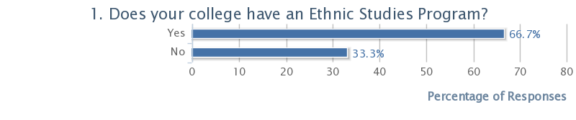
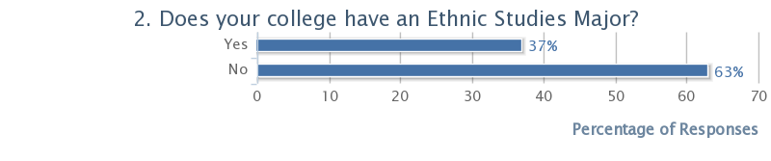
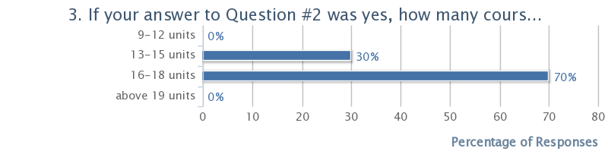
The majority of the respondents teach at schools that have Ethnic Studies programs and offer Ethnic Studies as a major. This is most likely attributable to the fact that the majority of the instructors contacted teach at schools with such offerings (i.e. Laney and CCSF). In addition, a strong majority (70%) of the respondents report that the unit requirements to earn a major degree fall within the 16-18 unit range. Currently, Chabot requires students to complete 21 units to complete the major. Considering the number of units required at neighboring institutions, the financial demand for college-wide course reductions and the increased pressure on students to complete their studies in a more timely fashion, there is a need to re-examine the number of units required at Chabot.
Nature of the Ethnic Studies/Cultural Diversity Requirement on Campus
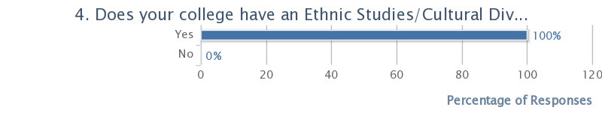
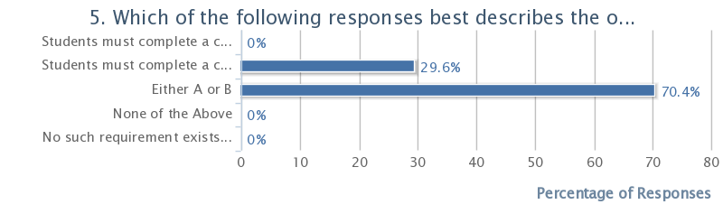
All the respondents teach at institutions that have some type of Cultural Diversity graduation requirement. A significant majority (70.4%) reports that this requirement can be fulfilled by taking either a course that focuses on the “experiences of an ethnic or racial minority” or a course “that compares the experiences of different peoples of different races/ethnicities.” A much smaller percentage (29.6%) reports a more restrictive requirement that necessitates the completion of a class that is singularly focused on an ethnic/racial minority. (After reading the course catalogs of each of the institutions potentially participating in this study, it appears the some of the respondents are mistaken in their impression that their institution requires students to take single-focused courses to fulfill this requirement.) No respondent reported a requirement, such as Chabot’s, which mandates that students take a course that “discusses and compares the experiences of different peoples of different races/ethnicities.”
While there is not necessarily a causative effect between the restrictive nature of Chabot’s American Cultures requirement and the decline of Ethnic Studies on the campus, there is certainly no incentive for students to take (nor teachers to develop) classes focused on one racial/ethnic group. On page 16 of my original sabbatical report, I put forth a case for a less restrictive requirement that would allow for students to complete the requirement in a manner that aligns with other community colleges in the region.
Presence, Characteristics and Goals of Introduction to Ethnic Studies Course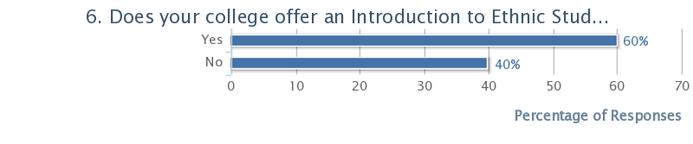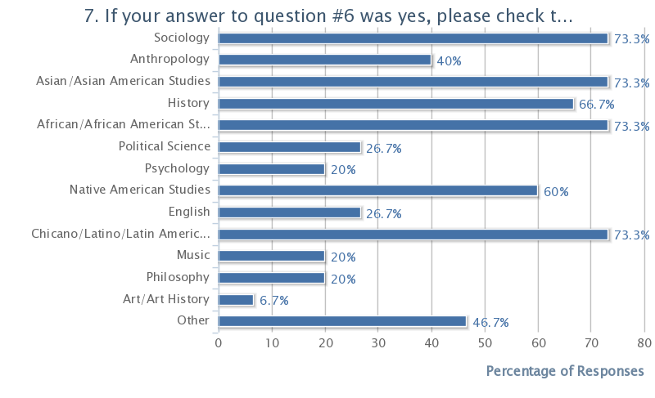Most respondents (60%) report Introduction to Ethnic Studies as a course offering on their campuses. In the survey, the definition of this introductory class included by both “a general Intro course or an Intro course focusing upon one ethnic/racial group.” The results probably reflect this expanded definition.
As significant, was the range of disciplines reflected in these courses. The responses to question #7 reflected a wide variety of discipline represented in the introductory courses. As an interdisciplinary field, this outcome is not necessarily surprising. The older disciplines of Sociology, History, and Political Science are certainly a significant presence among those identified. My inclusion of the relatively newer (at least compared to the others) disciplines of African American-, Asian-, Chicano/Latino-, and Native American- studies allowed respondents the flexibility to self-identify the fields in which they taught. I suspect there is a bit of double-dipping occurring in the results of this questions as some respondents may view their inclusion of the race-specific ethnic studies categories as duplicative of some of the other categories with which they were presented. Still, it was important to me to try to capture some measurement of how the respondents included and viewed the fields in which they taught as disciplinary.
8. If your college offers an Introduction to Ethnic Studies course (focusing on one or more racial/ethnic groups), what would you say are the primary curricular goals in this course? (e.g. skills, theories, body of knowledge)
I intentionally worded this question to avoid the term “student learning outcome”. Given the significantly negative attitudes circulating around this term and its implementation, I felt that utilizing it in the survey could possibly affect the response rate to the survey or, at least this question. Instead, I chose to use the more general term, “primary curricular goals,” to capture similar information. Thus, the responses might not represent that actual SLOs of the respondents’ courses, but do, I hope, reflect what they value in the curriculum of these particular classes. Below are a large sampling of the responses:
The course is an introduction to African American studies and its multiple approaches to the study of the lives and experiences of African Americans. As such, the course studies the operation of race in the United States and its evolution over time.
Providing students with the multiple approaches to study the history, society and cultures of Chicanos/Latinos.
The purpose of the course is to provide students with both an intro to the experiences of a spectrum of racial minorities, and a framework to understand those experiences.
The goals are the study of the diverse experiences and cultures of peoples of color
In this class, African American history and racial experiences are discussed. It is important that students understand the workings of race and how it is connected to them in the present day.
Introduce students to Asian American history, society and culture.
The goal of the class is to introduce students to the experiences and issues of Chicanos from an interdisciplinary perspective
The goal of the class is to survey the history, culture, problems and conditions of American ethnic minorities and the effects or racism, prejudice and discrimination on emerging minority groups in the United States
I feel the primary goal of the class is to introduce students to the concepts and history of race as a form of oppression.
The major goals are to provide a comparative analysis of race. I think it is important for students to see different racial experiences.
The class is an overview of the more specific offerings in the Ethnic studies program.
The goals include coverage of the major racial minorities in America and the study of race and ethnicity as social categories.
To teach the mechanics of race and ethnicity in the US

If there are patterns to these responses, they are reflected in the desire to present a varied analysis of race and to study the particular historical experiences of racial minorities. As introductory courses there is a degree of sampling that appears to be taking place. That is, many of the classes are intended to be a gateway to more in-depth study and investigation provided in other Ethnic Studies classes offered beyond the introductory class. This question leads directly to the next level of inquiry.
Presence, Characteristics and Goals of Ethnic Studies Program/Major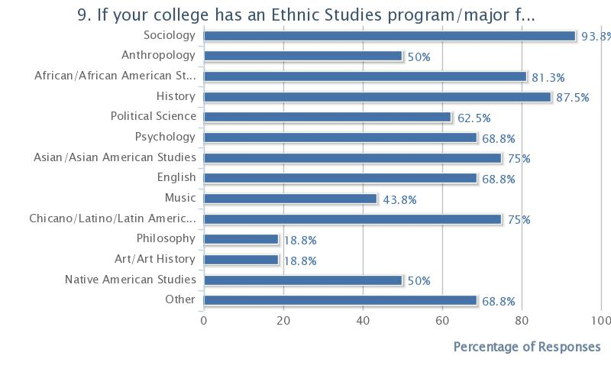
Certainly, there were fewer respondents to this question (16 out of 27). Those that did respond provided evidence of the wider range of disciplines represented within Ethnic Studies programs. Disciplines such as English, Psychology and Music which may not have been considered part of the core offering in the introductory class are much more significantly represented in the broader offerings of those colleges with Ethnic Studies programs/majors. Equally significant may be the “Other” category. Nearly 70% of the respondents identified Ethnic Studies program coursework in this category. An examination of the course catalogs reveal that disciplines that may be included in this category are Religious Studies, LGBT Studies, Theatre Arts, Philippine Studies, and Labor Studies.
10. If your college offers an Ethnic Studies major (focusing on one or more racial/ethnic groups), what would you say are the primary curricular goals in this major? (e.g. skills, theories, body of knowledge)
Again, my choice of wording in this question reflected the general negative perception of the language of learning outcomes. My decision to re-use the phrase “primary curricular goals” (rather than, for example, Program Level Outcome) was an attempt to avoid attaching those negative perceptions to this survey. Below are the responses I received:
See Above
See Above
The primary goals are to introduce the study of race through the presentation of interdisciplinary approaches to the study of this category.
See Above
The goal of the program is to survey the history, culture, problems and conditions of American ethnic minorities and the effects or racism, prejudice and discrimination on emerging minority groups in the United States
See Above
To provide a basic coverage of the experiences of people of color and the mechanics of race in the US

There were fewer respondents to this particular question and many simply referred to their answers to question #8 to indicate their goals. These goals largely circulated around the efforts to provide an interdisciplinary structure to frame the social, economic, political and cultural experiences of peoples of color. While it appears the more respondents could have answered this question, some chose to simply skip it.
Ethnics Studies and Learning Communities
Three survey questions focused on the connection between Ethnic Studies programs and learning communities. My interest in this connection stem from my current participation in a learning community at Chabot (Daraja) and the efficacy of creating links between this and other learning communities (e.g. Puente) and a revitalized Ethnic Studies program. Would such a link aid students in their second year? Could retention/persistence be increased? These are some of the questions behind this small section of the survey.
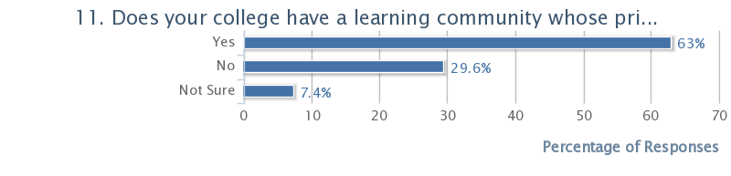
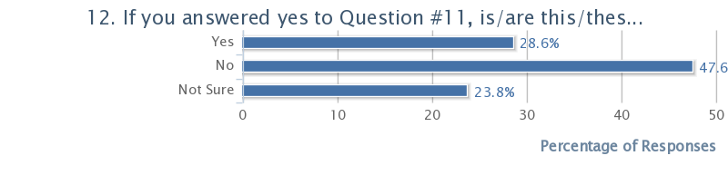
A significant majority of the respondents reported teaching at colleges with race-specific learning communities. A larger majority, however, reported that there was no (or they did not know of any) link between these communities and their Ethnic Studies programs. There were few respondents who did record a link:
13. If you answered yes to Question #12, please briefly describe the connection the learning community and the Ethnic Studies program.
Shared coursework
Students take classes in the major.
Coursework
A program embedded in a program. The students receive counseling support and an intro to college support.
Coursework
There is a program in which classes within the program overlap with Ethnic studies classes

Those few connections that were reported appear to be the inclusion of courses from within the Ethnic Studies program in the program of study that have been created by the learning communities. One reported connection also claimed that counseling support also linked the learning community to the program. This topic of counseling support became an important discussion point during the interviews and will be considered in greater depth in that section of this report.
Strengths and Weaknesses of Ethnic Studies Program
The last two questions of the survey focused on the perceived strengths and weaknesses of the respondents programs. My inclusion of these questions were and attempt to capture the programmatic successes and smart ideas and also the needs, and potential stumbling blocks in revitalizing the program at Chabot.
14. What do you see as the strengths of the Ethnic Studies program at your college?
The program provides a community for African American students to explore their racial experiences and provides a structure for understanding those experiences.
The strengths of the program include the breadth of the classes offered.
The classes offered to students provide a good foundation for the study of race and the history of racial minorities.
The program provides a good interdisciplinary intro into the area of race and gives students a good foundation for their continuing studies after transferring.
We are particularly strong in African- and Asian- American Studies.
The basic skills support students receive.
The program is comprehensive
The variety of programs on the campus reflect the diversity of our students.
The diversity of our students is a great strength.
We do a good job of introducing the conversation of race to the students. They see race (and their experiences of it) as a legitimate area of study.
The faculty is committed to the students and their academic needs.
We do a pretty good job with coverage.
The breadth of the offerings

The reported strengths highlight the pride that the respondents feel in the breadth of the Ethnic Studies offerings their colleges provide. Most seem to be very satisfied with the curriculum and its reflection of the diversity on these respective college campuses. References to faculty commitment, “doing a good job,” and particular “strengths” demonstrate that these Ethnic Studies instructors are determined in their efforts to provide a strong foundation in the field. What is somewhat lacking in these responses, however, are specific programs, policies, curricular choices that shape this determined pride. Perhaps the phrasing of this question could have been more specific to have elicited such responses.
15. What do you see as the weaknesses of the Ethnic Studies program at your college?
It would be helpful to provide more community opportunities and mentoring for our students.
offer more sections
Providing an intro class good be a good gateway into the major.
We need more sections of the intro class
We need to expand the amount of support students receive
More service learning please
More class offerings
I don't think the program has grown to truly reflect the diversity of our students.
I think we need to do a better job of increasing the number of majors.
I think we need more course offerings.
We could offer more service learning opportunities and counseling support.
More offerings
More counseling support and FTEF

The answers provided for the last question were more specific. Indeed, the focus of these responses seem to reflect less upon the specific weaknesses of the respective Ethnic Studies and more upon the perceived need for additional resources to support students. The major area around which these needs occur is counseling. This area of concern is largely connected to college-wide budgetary and prioritization decisions outside of the programmatic decision-making power Ethnic Studies programs have. In addition, these perceived weaknesses became discussion items during the interviews conducted as a part of this project. Again, these items will be discussed in that section of this report.
Ethnic Studies Interviews
Those instructors who agreed to be interviewed did so with the understanding that they would remain anonymous for the purposes of reporting. With this agreement, the conversations that were held were open and frank. The conversations lasted from 20-30 minutes and were conducted in person on the interviewees college campuses. These in-person interviews allowed the interviewees to choose spaces in which they felt most comfortable and allowed me to visit campuses.
--Discussion Themes
Introductory Questions
The conversations began with general questions focusing primarily on the curricular goals of the Ethnic Studies introductory course and/or Ethnic Studies major of the respective colleges. The responses to these opening questions largely reflected the responses I had received on the survey. Interviewee #1 claimed that she “hoped to give student that language and framework to understand their own racial experience.” Interviewee #2 stated that “giving the students the history they should know about themselves” was very important. Interviewee #3 stated that “the central focus of the intro class was to demonstrate the fluidity of race, to show its constructed nature.” All the interviewees seemed satisfied with the Ethnic Studies curriculum offered at their respective colleges, commenting that “we have pretty good coverage here” (Interviewee #4) and “the students are well served by the coverage this college offers (Interviewee #3).
One question I posed to which there seemed to be no consensus response was “Do you think an Introduction to Ethnic Studies class is necessary to an Ethnic Studies program?” Interviewee #2 thought that there were “a number of Social Science classes” that could perform a similar function. Interviewee #1 maintained that the “intro class gives students a foot in the door” of the major. The other two interviewees also expressed divergent opinions about the necessity of the course. Certainly these differing opinions might reflect the personal investment each interviewee has in the Intro course offering. Given the fact that the schools included in this study span the range of possibilities in this area, however, does suggest that some examination of the necessity of the Intro class should be done.
Major Themes
-Persistence and Success. Surprisingly, each conversation with the interviewees drifted toward discussions of students. The perceived “weakness” in their programs was in their ability to keep the students in the classroom and on track. Each interviewee expressed great concerns about the academic skill level of his/her students and their ability to persist. Interviewee #4 stated that she “seemed to be losing more and more each year,” while Interviewee #1 was “spending more time just trying to get students to come to class.” Interviewee #3 suggested that it just “wasn’t the fact that many of my students don’t seem prepared, they also seem to lack the motivation to succeed.”
When asked how each attempted to address these concerns, the replies varied. Interviewee #1 listed different strategies she has used including, “establishing study groups, adding library skills to the class and expanding office hours.” Interviewee #2 “attempts to connect students to tutoring and counseling services.” Interviewee #3 has also added “group work and more in-class writing” to help develop skills. Interviewee #4 includes additional “handouts” and “mini-exams” to get students to maintain a “consistent effort.” None of the interviewees view these strategies as comprehensive or, ultimately, fully addressing the issues they face in the classroom. Rather, they seemed to underscore the need for additional support outside the classroom.
-Counseling support. All of the interviewees stated the need for more student services. Interviewee #4 stated that “it’s hard to watch them struggle past my ability to help them.” Both Interviewee #1 and #3 see the cuts in counseling at their schools as “having an impact in my classroom” and “cutting a thin lifeline” that students desperately need. “My students need help beyond what I can give them in the classroom,” reported Interviewee #2. Continuing, she suggested, that “I’m convinced that these students need instruction on the basics, not just English and Math. They need to be taught how to try, how to succeed. That can’t be done in the classroom, or at least completely in my classroom. More of them need to be in college success-type classes, maybe in these types of classes linked to their academic courses.” I find this idea, in particular, a compelling notion. During this conversation with Interviewee #2, she suggested that I become more familiar with the research literature on non-cognitive skill development (also discussed as “habits of mind”). As this interviewee suggested, this research increasingly points to the potential of “teaching students to keep coming back, to keep trying even when it gets hard.”
The interviews revealed the primary concerns of these Ethnic Studies faculty to be less about the direction of their programs and more about their programs’ capacity to serve the increasing needs of their students. These concerns, institutional in scope, may hit Ethnic Studies programs harder. How, then, can Chabot revamp a program, that will likely serve a student population in need of academic and non-academic support?
Recommendations
Short-term recommendations (“Easy steps”):
- An Ethnic Studies Working Group should be established to review, run and advocate for the Ethnic Studies program at Chabot. This group should review the other recommendations of this report before implementation.
- As stated in the original sabbatical report, the Chabot College Ethnic Studies major requires 21 units for completion. This requirement, compared to similar programs on other campuses, is on the higher end. The number of classes should be reduced by one course for a total of 18 units.
- The classes listed on the original report (pages 18-19) should be officially added to the Ethnic Studies major. The additional classes will give students more options in completing the major.
Mid-term recommendations (Steps requiring significant college resources and/or significant changes to the major):

- Ideally, the college would prioritize the hiring of an instructor to teach Ethnic Studies. My recommendation would be that this hire by half-time in history to teach the Mexican-American history class and half-time in Ethnic Studies to develop and teach an Introduction to Ethnic Studies class. This class would not only fulfill the American Cultures requirement, as currently constituted, but also serve as a gateway course into the major.
- If the above recommendation cannot be accomplished, FTEF should be approved to hire an adjunct to teach, at least, one section of Introduction to Ethnic Studies. This hire would serve as a stopgap measure on the way to achieving the above step
- If neither of the previous two steps can be accomplished, the Introduction to Ethnic Studies should be eliminated. The major requirement could be fulfilled by requiring both Sociology 3 (American Cultural and Racial Minorities) and Anthropology 5 (Cultures of the U.S. in Global Perspective).
Long-term Recommendations (Difficult conversations):
- The college needs to revisit its implementation of the American Cultures requirement. All the colleges in the comparison set of this report allow students to fulfill their comparable requirement through the completion of either a class focused on one ethnic/racial group or a class that discusses multiple ethnic/racial groups. The fact that Chabot requires the latter may have a played a role in the declining state of the program. In addition, the requirement as currently structured effectively discourages faculty from developing and students from taking classes that focus on the experiences of one group. What are the pedagogical reasons for the original implementation of this requirement? Are these reasons applicable to the college as it currently exists? Should Chabot’s status as a Hispanic-serving institution be cause for reconsideration of the requirement in its current form? Should the requirement be revisited to open up the requirement to a broader spectrum of identification (e.g. gender and sexual identity)? These are all questions that should be opened to discussion and debate.
- During the interviews, I was struck by the consistent concern about student preparedness and persistence. While it is beyond the scope of this study to provide specific recommendations to address what is clearly a college-wide problem, it is apparent that the students most likely to be drawn to and participate in an Ethnic Studies program are those that, statistically, are most affected by the issues of preparedness and persistence. Perhaps, the Ethnic Studies program, in concert with other existing programs, can serve as a campus site through which these issues can be studied and solutions piloted.
One such pilot program could work to connect Ethnic Studies to the two established learning communities on campus focused on two separate communities of color –Daraja and Puente.
The first step of this pilot could be to study persistence rates in these programs. Daraja currently does not provide Psych-Counseling classroom support. Puente does. What impact, if any, does this difference have upon persistence and success rates? Are there specific non-cognitive skills provided in these classes that can (or do) aid success in other academic classes? Can these classes be fully aligned with the academic classes students take?
The second step of this pilot could be to provide a second year of Psych-Counseling classroom support within the Ethnic Studies Program. That is, those students within both Puente and Daraja whose interest lead to Ethnic Studies could be provided with continued support to aid in the development of their non-cognitive skill set. The persistence and success rates of these students could be studied against those whose participation in these learning communities ended with the first year.
Certainly, major details of such an undertaking need to be fleshed out. My hope would be that an Ethnic Studies Working Group, consisting of faculty, counselors, learning community representatives and others could work as an ongoing site for the development of curriculum and effective interventions aiding the improvement of persistence and success.
Again, my continued investigation to revitalize the Ethnic Studies program at Chabot, has taken me in unexpected directions. Many of the recommendations in this second part are repeated from the first part of my report. Most of these proposals are attempts to reimagine the Ethnic Studies program best suited for the college and its constituents. It simply makes sense to me to make any changes to the program student-centered. That is, the point of renewing this program should be not only to ensure its institutional survival, but also to improve student success.

Chabot College Office of Institutional Research, Chabot College Student Characteristics, Fall 2011 Census, 2011
Ohlone does not have an Ethnic Studies program. It does have a Chicano Studies Program and lists in its catalog and Introduction to Ethnic Studies class which is listed as Interdisciplinary Studies 110.
Laney College, LaneyCollege Catalog, 2011-2013 (2010), 219. See also, Chabot College, Chabot College Catalog, 2010-12, (2009), 127; San Jose City College, San Jose City College Catalog, 2011-12 (2010) 154; Evergreen Valley College, Evergreen Valley College Catalog, 2011-12 (2010), 103.
Laney College has an Ethnic Studies Department in which separate comparative Ethnic Studies, African American, Asian/Asian American, Mexican/Latin American Studies, and Native American Studies areas of study and majors exist and are given separate designations .While Laney has an Introduction to Ethnic Studies class in its catalog it does not require the course for its Ethnic Studies major or any of the separate areas of study/majors. Laney does require and Introduction to African American Studies for its African American Studies major. I have counted that course in this chart.
One difficulty in arriving at an accurate accounting is that each school categorizes its courses in unique ways. For example, Laney houses its African American history classes within African American Studies. Chabot houses these same courses within its History discipline. I’ve followed the designation that each college has devised as it represents, at least in part, how each college views the programmatic purpose of these courses.
See Ayaan Gates Williams, “BSU Demands Ethnic Studies faculty,” Laney Tower November, 1, 2007
The College also might want to consider reducing the number of units required within the Ethnic Studies major. Of the colleges surveyed, Chabot requires the highest number of units to complete the major. In addition, the Ethnic Studies major requires more units than most majors on the Chabot campus.
Given the fact that Latinos and Asian Americans make up nearly half of the student body of Chabot (and that Chabot is striving to be federally designated as an Hispanic-serving institution) it is depressingly ironic the degree to which these students are curricularly underserved by the college.

